**FINAL REVISIONS**

**HOME PAGE (subheading)**

At Nyxsys Philippines, Inc., we transform business growth with Digital Out-of-Home (DOOH) media and innovative technology solutions. Our advanced tools empower companies to enhance their presence, engage audiences, and thrive in the digital age. By delivering impactful campaigns and scalable solutions, we help our partners set industry standards, stay ahead, and achieve lasting success.

**OUR SERVICES (subheading)**

We provide comprehensive digital advertising solutions, blending innovation and expertise to meet business needs. Our services include LED billboard media, static inventories, seamless tech integration, data analytics for insights, and content management systems for efficient execution, empowering businesses to elevate marketing strategies and achieve results.

**WHO WE ARE (subheading)**

At Nyxsys Philippines, we help businesses thrive in the digital age with Digital Out-of-Home (DOOH) media and innovative technologies. Our platforms, from high-impact billboards to immersive displays, engage audiences with real-time content. By integrating data-driven insights and cloud-based solutions, we boost brand visibility, streamline operations, and drive sustained success. We’re shaping the future of brand communication, enabling innovation and growth with strategies that deliver transformative outcomes today and beyond.

**MEET OUR TEAM (subheading)**

A team of dedicated professionals driving innovation and success. With diverse skills and expertise, we collaborate to deliver impactful solutions, achieve exceptional results, and adapt to the evolving tech and business landscape. Together, we turn ideas into reality, helping clients thrive in a dynamic world.

**LED MEDIA INVENTORIES (landing page-subheading)**

Maximize your brand’s visibility with Nyxsys’ high-impact LED media, strategically placed in prime locations for optimal exposure. Our dynamic displays captivate audiences, providing unmatched reach and lasting impressions in urban centers, highways, and commercial hubs, helping your brand stand out in a competitive landscape.

**STATIC INVENTORIES (landing page-subheading)**

Achieve consistent brand exposure with Nyxsys Static Fixed Inventories, strategically placed in high-traffic locations. These high-quality, non-digital ads offer timeless, cost-effective visibility, ensuring your message resonates day after day with clarity and professionalism.

**BUSINESS INNOVATIVE SOLUTIONS & SERVICES (landing page-subheading)**

We empower your business with innovative solutions to drive growth, enhance efficiency, and gain a competitive edge. From advanced technologies to tailored strategies, we provide the tools and expertise to optimize performance, expand reach, and adapt to market demands, ensuring sustained success in a changing landscape.

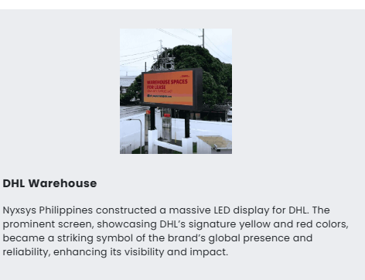

Replace write up for DHL: Nyxsys Philippines, the first in the Philippines to offer solar-powered LED displays, constructed a massive LED screen for DHL. The prominent display, featuring DHL’s signature yellow and red colors, became a striking symbol of the brand’s global presence and reliability, significantly enhancing its visibility and impact.

Change to “Helpdesk Support” instead of 24/7 helpdesk.

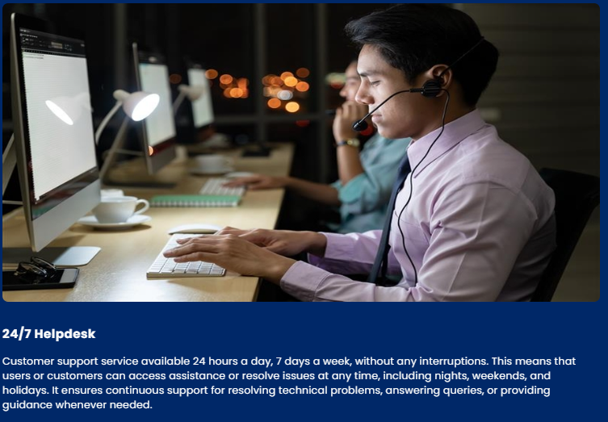

Put this call to action below the feature benefits: Ready to experience the power of digital media? Visit [vcastplay.com](https://vcastplay.com/) and try it for free today! Don't miss out—get started now!

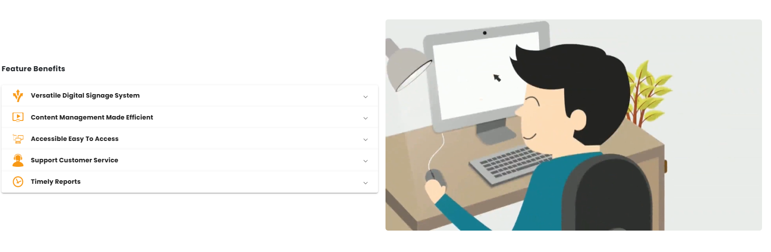

**AUDIENCE MEASUREMENT ENABLED BY CALTONDATX (landing page-subheading)**

Unlock the power of data-driven insights to better understand your audience. Our advanced analytics capture real-time engagement, uncover behavioral patterns, and reveal audience preferences, enabling highly targeted campaigns. Optimize strategies, enhance effectiveness, and stay ahead in a data-driven world.

Make a slideshow of the 3 pictures sent in MS Teams on this part.

